Black Lives Matter:
A Guide on Taking Action by Start: Empowerment

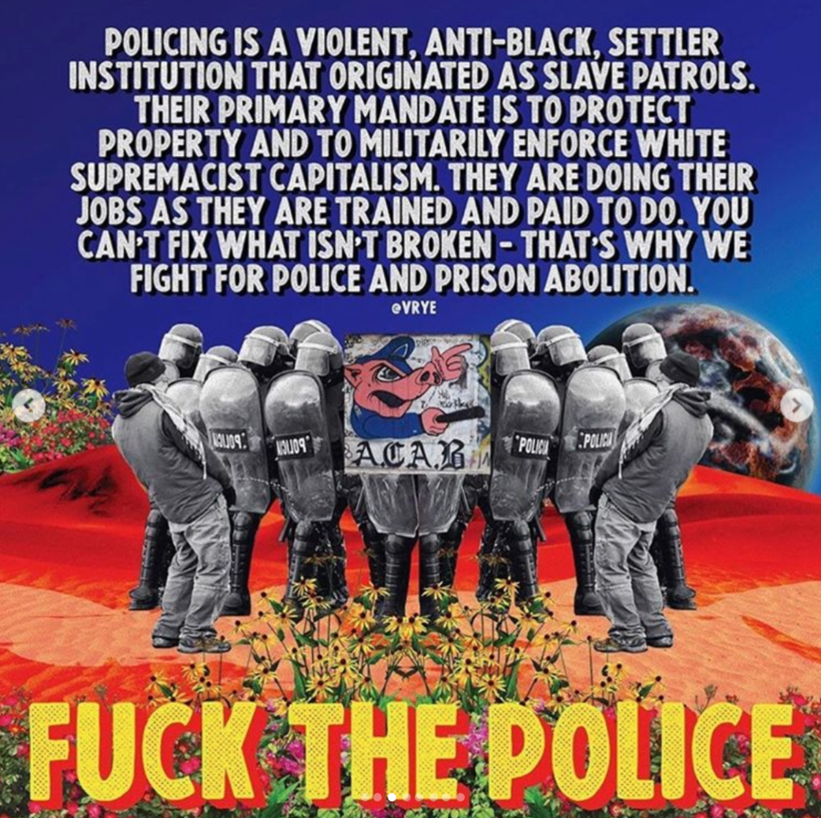

We seek to abolish the police/prison system by establishing alternatives to this inherently racist system that oppresses Black people and other POC. Here are some tools to help you do your part. Below are some resources to help you take action.

An updated database of all protests happening across the U.S. by Youth Climate Strike
https://docs.google.com/document/u/2/d/e/2PACX-1vSc21IFAQipNs9ReAzR_z_MuwqEsJk-LCDZ9l1jfBDcgny0pqQxL86IgNfJFjJOV6DkTMg39hl3ZyCY/pub

Action Steps

- “Justice for George Floyd: Action Steps”, a list of petition links, places to donate, education materials, and contact info for elected officials & police
  - https://docs.google.com/document/d/e/2PACX-1vRXZpNSnGFcNbeJoKlF8FTJ7iCK4zlCfGks1dOKDI_HtB8pIGj_517YJR9YhVEvcjYRZQxJyu6rANWW/pu
- Here’s a document including donation links, scripts for contacting government leaders, how to prepare for a protest, where to donate physical supplies, petitions, and protest updates
  - https://docs.google.com/document/u/1/d/1-0KC83vYfVQ-2freQveH43PWxuab2uWDEGolzrNoIks/mobilebasic

Resources & Ways to Take Action:
- Black Lives Matter & COVID-19: An Activist Roundtable
- We're Sick of Racism, Literally
- Embracing Sadness When Joy & Rage Are the Only Options the World Offers to Black People
- How White People Can Hold Each Other Accountable to Stop Institutional Racism
- How Videos of Police Brutality Traumatize African-Americans and Undermine the Search for Justice
- Anti-Oppression: Anti-Racism Guide
- Taking a Stand Against Police Violence
- Reclaim the Block
- Justice for Breonna Taylor
- Black Lives Matter
- Campaign Zero
- Justice for Big Floyd
- Justice for George Floyd
- #JusticeforFloyd
- Hold conversations with your friends, family, neighbors
  - Ask your family what they think of recent events. Start the conversation and then follow through! If you have racist family members, confront them! If you have neutral/”not-racist” family members, make sure they understand why it’s important to be anti-racist.
  - Advise your family to donate money to Black organizations
- Jail support
  - If you know people are being arrested and where they've been taken, try to find out when they’re being released and be there w/ food, water, and painkillers for them when they get out.
  - Some groups are setting up shifts outside of jails to help fellow protesters when they’re released. Consider joining one of these groups or starting one of your own.
  - You can call an Uber home for families and friends who have been waiting for their loved ones to come out.
- If you have a car, you can drive around protests, identify medic tables, and drop off baking soda, water, goggles, painkillers, and t-shirts. Protestors need these items, since the police are constantly trying to provoke and attack them!
- Get together with a friend or family member and listen to police radio to warn protestors of their plan and record illegal and racist dialogue among police.
- Help organize mutual aid, food banks, and community resources for Black people and/or support existing networks led by Black people.
- Turn off your ad blockers and stream this youtube video to raise money for BLM:
  - https://www.youtube.com/watch?v=bCgLa25fDHM
- Email lawyers in your city to ask if they will represent arrested protestors pro-bono, then gather this information to spread it through community networks and social media. Here is a template for contacting lawyers:
  - https://docs.google.com/document/u/0/d/1zvLnH3pn4I7JxUa88-cDNodDlsprE6htCp-Txq249OI/mobilebasic
- Support Black businesses all-year-round! Here’s a twitter thread (with links) to help you:
  - https://twitter.com/jadealycebod/status/1266573372370059266
- Here’s a list of bail funds to donate to
  - https://docs.google.com/spreadsheets/u/1/d/1ZIvDZpHqvNZkf8dGFXVjfk-Wq0Y9FTG410NJbH_8K8M/htmlview
- Here’s another list of bail funds to donate to + lawyers you can contact if arrested
  - https://docs.google.com/document/d/1X4-YS3vFn5CLL9QtJSU0xqmTh_h8XilXgOqGAjZISBI/preview?fbclid=IwAR2trHe9Uh9WA6R1l_KagmyNVnpG0m157YKe9gwWFesRwOoHUlr6GKhlFxQ&pru=AAABcopMPQU*K_puEnU-cBUGKdR1iGi4tA
- Email your teachers, principal, superintendent, school board to ask about including anti-racism training and education into your public schools.

Readings/education on racism in the U.S, policing, and the criminal justice system.

- Reading: Are Prisons Obsolete by Angela Davis
  - https://theanarchistlibrary.org/library/angela-y-davis-are-prisons-obsolete.pdf
- Reading + Watch List: Pandemic Revolutionary Reading / Film list by @joelibrahim_ (ig)
  - https://docs.google.com/document/u/0/d/1vMVDYyIfAOkdNeQPHwH2svgAdoh9PBfNILEP82WEU9Q/mobilebasic
- Reading List: Black Perspectives - College Level Prison Abolition Syllabus
  - https://www.aaihs.org/prison-abolition-syllabus-2-0/
- Video: Tedx Talk: Let's get to the root of racial injustice by Megan Ming Francis
  - https://www.youtube.com/watch?v=-aCn72iXO9s
- Reading list: The Reader guide to police abolition
  - https://www.chicagoreader.com/chicago/the-reader-guide-to-understanding-police-abolition/Content?oid=80272747
- Readings: Black Revolutionary Text
  - https://drive.google.com/drive/u/0/folders/18y0_2wm85L113fVWYdgljq9uuIlmlbl3
- Video/Live Panel: Black and Asian solidarity in NYC: What we have learned
  - https://www.facebook.com/watch/live/?v=1214147432261027
- Action List: 20+ Allyship actions for Asians to show up for the Black community right now by Michelle Kim
  - https://medium.com/awaken-blog/20-allyship-actions-for-asians-to-show-up-for-the-black-community-right-now-464e5689cf3e
- Reading List: Black Woman Radicals and AAFC Solidarity Reading List
  - https://www.blackwomenradicals.com/blog-feed/black-and-asian-feminist-solidarities-a-reading-list
- Article: Amy Cooper Knew Exactly What She Was Doing by Zeba Blay
  - https://www.huffpost.com/entry/amy-cooper-knew-exactly-what-she-was-doing_n_5ecd1d89c5b6c1f281e0fbc5
- Book Club: Algorithms of Oppression - a book club and study group by Mandy Harris Williams, free black women's library and women's center for creative work
  - https://womenscenterforcreativework.com/events/algorithms-of-oppression/
- Reading List: 20 Anti-Racist books by black authors
  - https://www.elle.com/culture/books/g32687973/black-history-books-reading-list/
  - & a site with over 6 million free books if you can't afford to buy the books: https://b-ok.cc/
- Video: Systemic Racism in the United States
  - https://www.instagram.com/tv/CA2C1FpHAky/?igshid=ixewwczbzwfy
- Reading List: A syllabus on Institutionalized Racism
  - https://daily.jstor.org/institutionalized-racism-a-syllabus/?fbclid=IwAR2lL8cG98Xu3apHGCmchwX7aEQRH1NtRiSQSPvELXz0hhDHOYLnvm67Vqk

“If you are neutral in situations of injustice you have chosen the side of the oppressor”
-Desmond Tutu

…...

(These were just other ideas, they don’t have to be in the letter.)
Here are some organizations that are making tangible change, e.g. the Color of Change and Campaign Zero.
See this poem about Letting America be America because We Are America vs. Making America Great Again.
Another organization Life After Hate is working to help people who choose to move away from following violent religious and ideological groups and reintegrate with society.
---------------
We must also recognize the history of oppression plaguing our Black womxn. Though some glimpse of justice is shown through the arrests of those suspects involved in the George Floyd and Ahmaud Arbery cases there have been no arrests made in the case of Breonna Taylor. Police violence and other violent acts against womxn of color is a huge issue in our society, though it often receives little to no media coverage and attention. The lack of coverage of the Breonna Taylor case, and other womxn-identifying Black persons in our media is noticeable and should also not be tolerated. In our quest to seek justice for victims in our Black communities it is vital that we recognize the intersecting identities of all those affected by systems of oppression and truly seek justice for all.

What occurred to Ahmaud Arbery, Breonna Taylor, George Floyd, and countless others is incredibly heartbreaking, but it is not new. It is the representation of a system of oppression that dates back centuries, and continues to manifest itself into injustices experienced by so many marginalized groups in various institutions within our society. What makes this experience unique is that it is paired with the intense magnitude of the stress that the world is experiencing by a global pandemic, bringing with it a huge health crisis and economic distress that also disproportionately impacts marginalized members of our society.

